Hits

So what are hits, a hit is when a single file is requested from your website. For example if you type in a website address and the home page is displayed then that is one hit.

Wrong, if there are six pictures on the home page then that is seven hits, the six pictures and the home page itself. Want to increase the number of hits on your website? Simply add more pictures.

Another way to increase hits are to submit your website to hundreds of search engines every day (there are companies who will do this for and many charge several hundred pounds a year for doing) so. EVERY search engine you submit to will request EVERY page from your website EVERY few days… loads and loads of hits!

Of course none of this means any more people are actually looking at your website! Hits are essentially meaningless as a measure of the number of visitors to your website. Most who reference the number of ‘hits’ are simply unaware of what a hit is, others who do so such as search engine submission companies will likely do so knowing they are deceiving you. Don’t buy into it!

So what should you look at? Below is an analysis of the Frock Factory’s statistics.

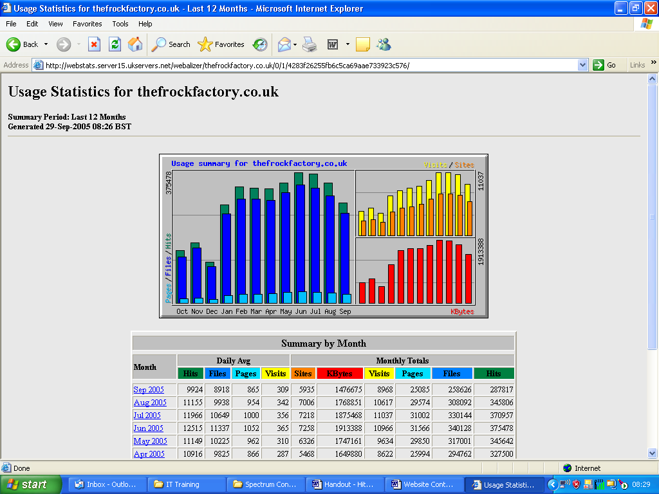

A much better measure is the number of sites, this is (albeit loosely) the number of distinct computers who have visited your website and therefore the closest figure you can get to the number of people who have visited.

In the above example in August the Frock Factory had 345,806 hits with a daily average of 11,115! However this equates to only 226 sites per day (7006 / 31).

Of course many of these will not be people at all, but search engines, such as Google, requesting pages from your website.

A website with 2000 hits in a day might well only have 40 people actually looking at it!

Far the most accurate of performance is this:

If your website require users to login you should be able to report on how many different people have logged in (and also how long they spend).

This will not of course include people who just scan your home page and click off somewhere else, but why would you want to? You cannot really count such a person as a visitor to your website; they are someone who’s merely glanced through the shop window as they walked by and decided yours is not worth opening the door to take a proper look.

N.B. The Frock Factory’s statistics look impressive, and indeed they are, but it is worth mentioning that the owner is a sole trader who makes bespoke dresses for around £300 each. In other words all this traffic to the website only supports ONE individual financially; it’s not a factory employing dozens of workers.

